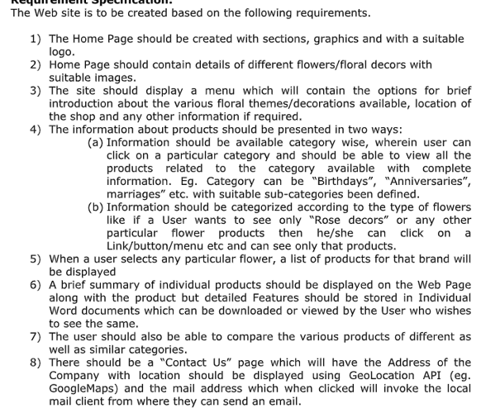

Lorem lorem ,lirl;wmdx x x a. xa x.x.XMamxsnsncnscsncnscnsmcwqcs,ncnqscnsc scnc sc scm,nsacnsqcn